Education Justice Project
Computer Lab Co-Coordinator Job Description

The mission of the Education Justice Project (EJP) is to build a model college-in-prison program that demonstrates the positive impacts of higher education upon incarcerated people, their families, the neighborhoods from which they come, the host institution, and society as a whole.

The Education Justice Project maintains a computer lab at Danville Correctional Center (see photo below). It’s one of the few dedicated computer labs run by a college-in-prison program, and it’s an important resource for the members of EJP.
The computer lab is used by many EJP programs, including for-credit course, writing and math partners, math and science workshops, Language Partners, and Evaluation. EJP students use the lab to produce assignments and notes for for-credit courses and other EJP activities they’re involved with, watch uploaded content (there is no internet), and gain comfort on a computer. Workshops are held in the lab around topics such as basic computer skills, keyboarding, and programming. Some instructors use the computer lab as a classroom.
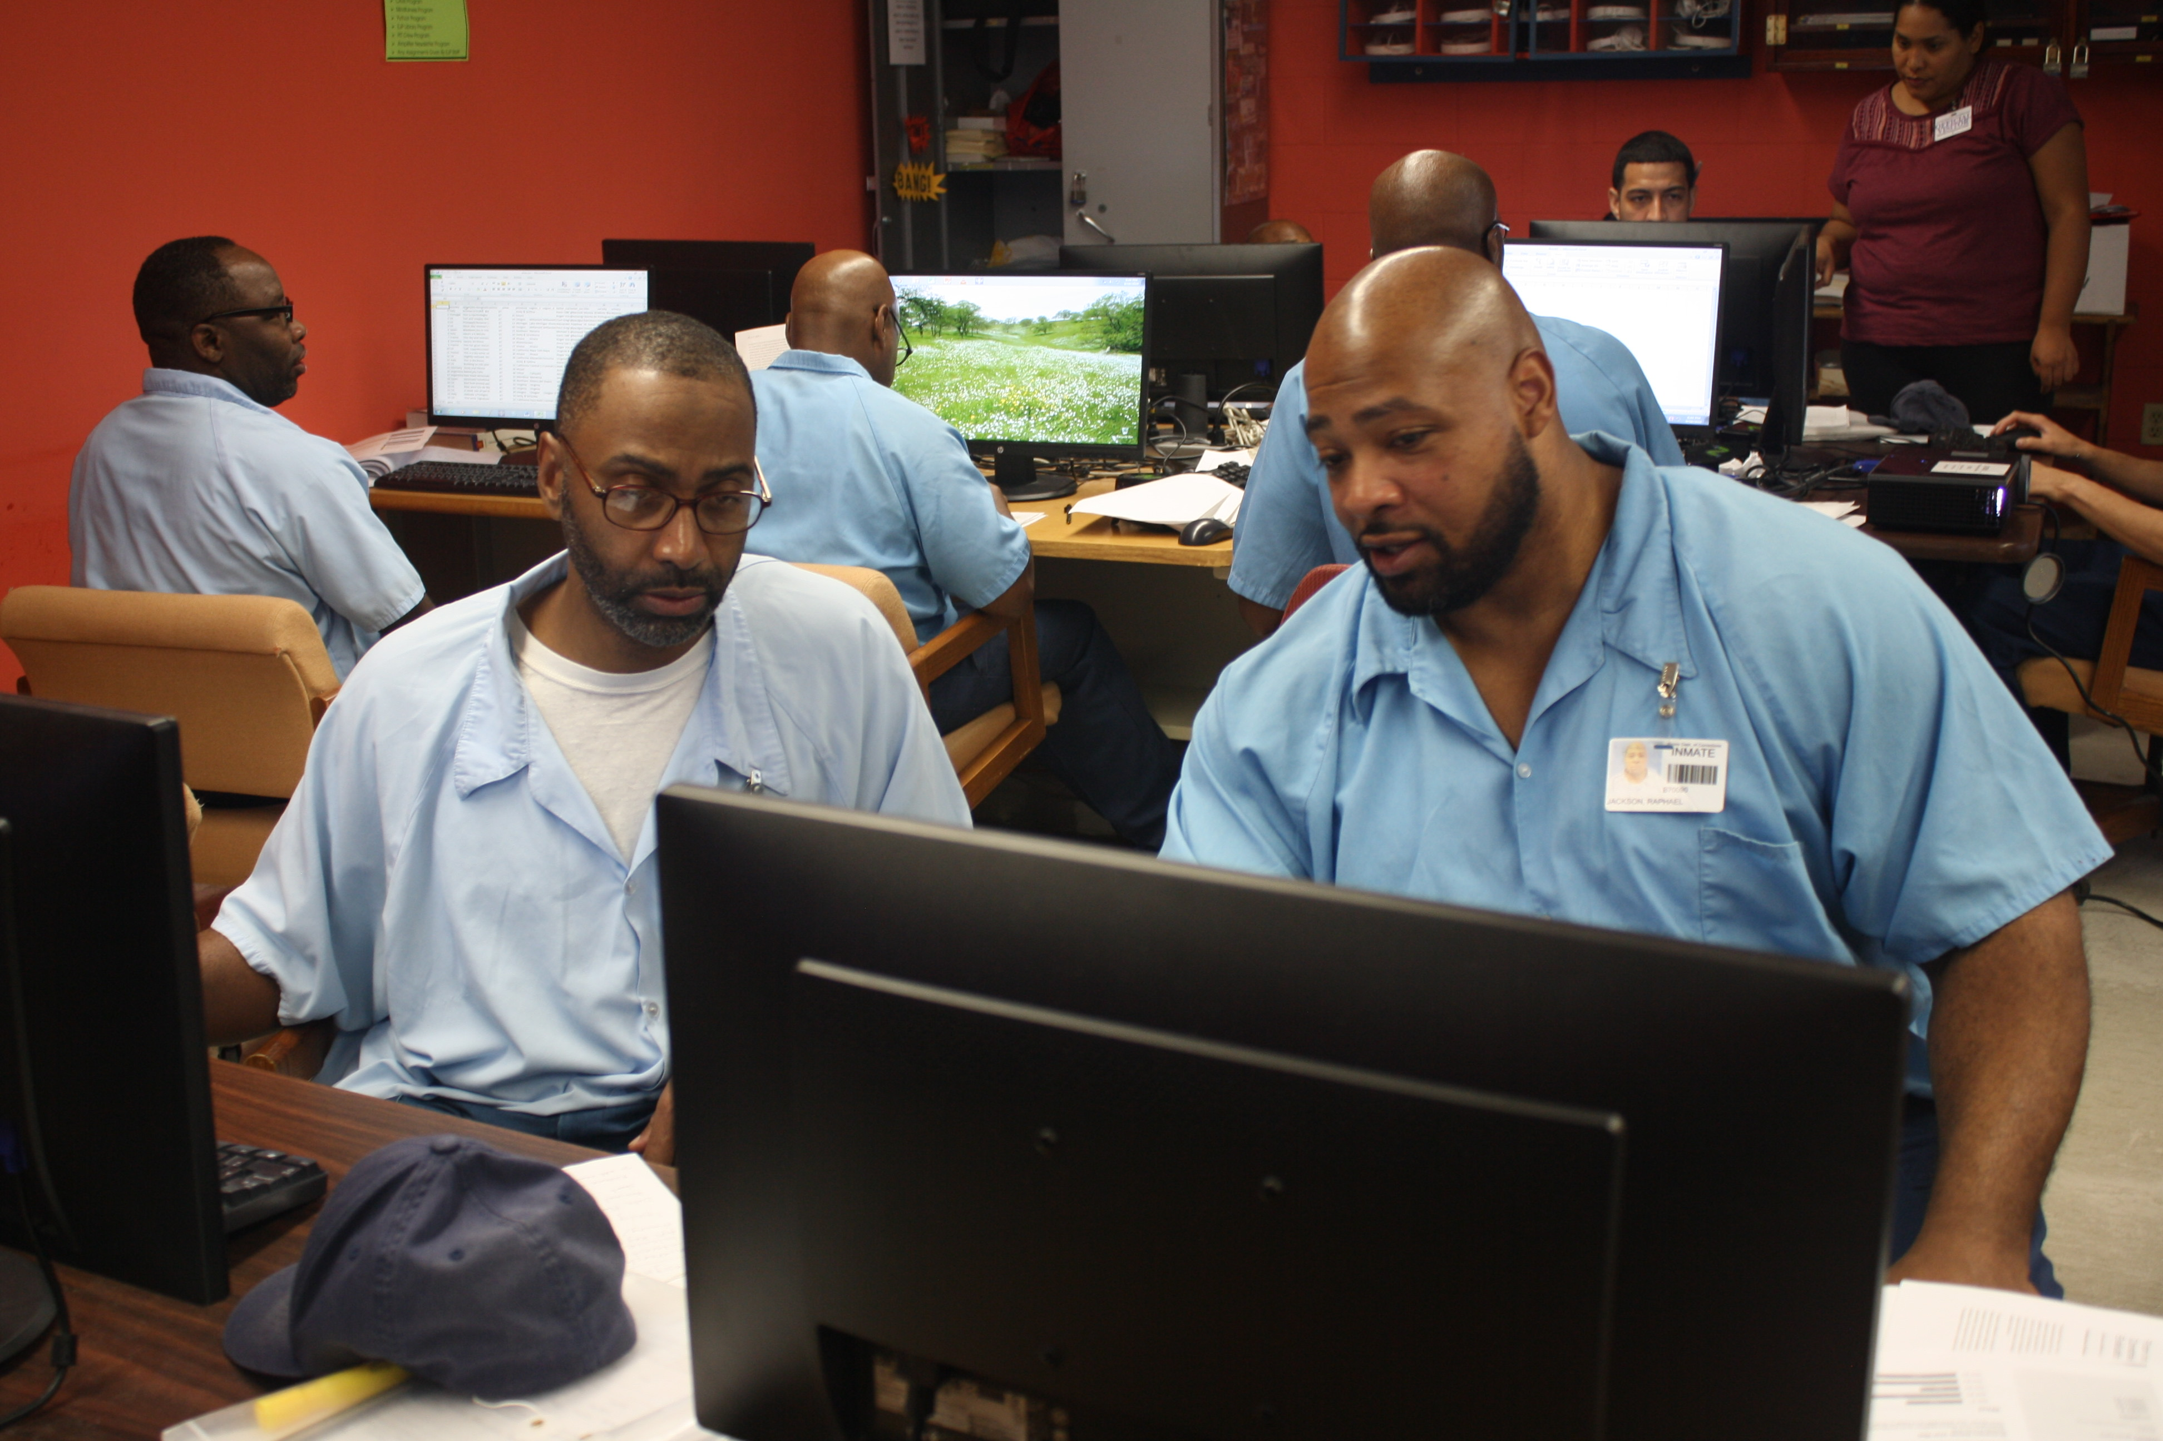

The EJP computer lab coordinator is responsible for managing the lab. We aim to have the lab serve as a purposeful “third space” – a valued and vibrant place that supports community building while comfortably and efficiently meeting the various functions that take place in the room. The coordinator does this with the support of members of the computer lab team and a group of incarcerated students who serve as the computer lab advisory committee.
The specific responsibilities of the coordinator include working with the computer lab team, the advisory committee, and other relevant entities to:
- Maintain the hardware in the computer lab. This includes addressing technical issues with the desktop server, workstations, laptops, and auxiliary devices (e.g., printers, scanners, projectors).
- Maintain the software library in the computer lab. This includes ensuring that software installed on the server is functioning properly, and adequate documentation is provided to students using the software.
- Ensure that EJP students and other key stakeholders are actively involved in lab management.
- Expand the hardware and software resources in the lab when funding is available. This includes assessing and selecting both new hardware/software and upgrades to existing hardware/software.
- Develop policies for computer lab use that are consistent with DCC’s and IDOC’s policies, and ensure these policies are known by students and instructors.
- Perform general maintenance and upkeep of user accounts. New EJP students and instructors should be provided with user account information promptly, and inactive accounts should be archived on a regular basis.
- Provide training on computer lab policies and general use of the lab to incoming EJP instructors and students. This training should also be made available to current instructors and students.
- Provide assistance at the request of EJP instructors using the computer lab. This includes providing training for software already installed in the lab and assisting with the clearance and installation of new software needed for EJP programs.
- Oversee "Pit Crew" operations and provide necessary feedback and resources for their growth and activities.

In addition, all EJP coordinators are asked to regularly evaluate their performance with respect to the following. Resources are available to support in these areas.
1. Communication
- sharing information, concerns, announcements, and more with EJP students, members of their program, EJP Director of Academic Programs, members of the public, and relevant others. Communication can be challenging in the prison environment, and EJP encourages coordinators to experiment with ways of sharing and hearing from others.

2. Monitoring
- ongoing assessment of the program and making fixes as problems arise. This includes collecting information to learn how things are going within the program and making use of that information to make changes to the program as required.

3. Nurturing
- guiding, mentoring, and supporting EJP members in the program. This includes identifying people in particular need of nurturing or mentoring and developing a nurturing culture within the program.

4. Decision-making
- exercising leadership and taking initiative. It could include making bold decisions regarding programming or operations, and to developing themselves as leaders (e.g. through workshops or readings).

Requirements
Required
Bachelor’s degree
Proven managerial or administrative experience
Good familiarity with computer labs
Demonstrated commitment to social justice values

Preferred
Familiarity with issues related to incarceration, criminal justice, reentry, and related matters

All applications are welcome. However, because EJP aims to create a supportive learning environment for our incarcerated students, we especially encourage applications from individuals whose backgrounds align with those of our students. This includes members of racial minority groups, first-generation degree holders, and individuals from low socioeconomic status backgrounds. . Please note that the EJP classrooms are on the second floor of the prison and that there is no elevator.

According to Illinois Department of Corrections (IDOC) policy, if you are formerly incarcerated within Illinois or are actively visiting a friend or family who is incarcerated in IDOC, it is unlikely you will be able to receive IDOC clearance. Unfortunately, this is beyond our control.

Application Process
To apply, please fill out the Computer Lab Coordinator application here. In the application you will be asked to upload a cover letter and CV (or resume).

Questions?
Please contact the Academic Director, Ellen Ritter at esritte2@illinois.edu.

Compensation
This position pays a stipend of $2,000/semester.

