Education Justice Project
Mindfulness Discussion Group Facilitator Application
Due October 3, 2022

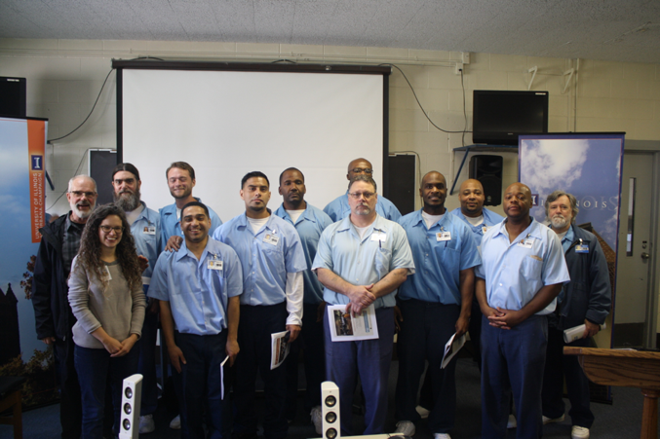
The mission of the Education Justice project is to build a model college-in-prison program that demonstrates the positive impacts of higher education upon incarcerated people, the communities from which they come, the host institution, and society as a whole.
What is MDG?

The MDG program aims to build a positive co-created community of mindfulness meditation learners. In this community, we uphold a holistic approach to learning, thus reading and discussing scholarly text is accompanied with the practice and discussion of mindfulness meditation during each meeting.

MDG meets on Thursday evenings from 5-8pm at Danville Correctional Center (DCC) including winter, spring, and summer break. To make our travel to Danville more pleasant and efficient we carpool, leaving around 4pm and returning around 9pm. About 10-15 EJP students participate in MDG each semester. Joining MDG would mean you are committing to attending our MDG meetings at DCC twice per month unless exceptions have been arranged with the co-coordinators.

What would your responsibilities be as a facilitator of MDG?

Timeframe | Responsibility
Daily | Maintain your personal meditation practice.
Monthly | Attend two MDG meetings as well as prepare and facilitate the MDG meeting’s activities as delegated (e.g., leading reading discussions, guiding meditations, etc.).
 | Attend a 1-hour MDG program planning meeting.
At least once per year | Participate in EJP outside of MDG activities, including attending at least one “critical climate” discussion per academic year (we will share more about these when we meet in person).
Ongoing/Varies | Stay on top of EJP & MDG communication efforts (e.g., reading/replying to emails regarding MDG, writing and posting MDG meeting summaries on an online platform called “Mango” when assigned, reading EJP Mango reports as appropriate).

Beyond these responsibilities, we also expect our members to:
- Uphold an inclusive MDG community culture.
- Embody the core attitudes of mindfulness (e.g., kindness, curiosity, openness, nonjudgment) throughout all MDG activities.
- Help us think boldly and creatively about the MDG program!

What kind of prior experience do we anticipate from our MDG facilitator applicants?

Required experience:
- Personal Meditation Practice – We expect our members to possess and maintain a sincere personal meditation practice that includes daily meditation practice.
Preferred experience (however, don’t let these keep you from applying!):
- Group Facilitation Skills – Experience leading small groups in a learning environment (e.g., teaching at a school or university, in courses you have taken, leading therapy-related groups, facilitating small church discussion groups, or other group facilitation experience where there is open dialogue and perhaps sensitive topics are discussed and facilitated by you).
- Formal Meditation Training/Experience – Experience taking formal mindfulness meditation classes such as an 8-week/20-hour secular meditation class (e.g., Psychological Service Center, (PSC) 20-hour Mindfulness Training), or regular attendance with a meditation group within a particular tradition for at least 6 months (e.g., Prairie Sangha, Prairie Zen Center). If you haven’t done one of these options, we can talk about how you can get this experience in a way that is accessible to you!
Please apply!

All applications are welcome. However, because EJP aims to create a supportive learning environment for our incarcerated students, we especially encourage applications from individuals whose backgrounds align with those of our students. This includes members of racial minority groups, first-generation degree holders, and individuals from low socioeconomic status backgrounds. Please note that the educational offices are on the second floor of the prison and that there is no elevator.

According to Illinois Department of Corrections (IDOC) policy, if you are formerly incarcerated within Illinois or are actively visiting a friend or family who is incarcerated in IDOC, it is unlikely you will be able to receive IDOC clearance. Unfortunately, this is beyond our control.

Please fill out an MDG application here.

After we receive your application form, we will contact you to discuss your application. Those who are accepted to work with MDG will be required to complete a lengthy clearance process by the Illinois Department of Corrections, a training session at Danville Correctional Center, and a half-day EJP training session on campus. Thank you, again. We look forward to receiving your application.

Questions?

If you would like to talk to someone about MDG prior to applying please email the MDG coordinator, Jonathan Cerna, at cerna3@illinois.edu

