Education Justice Project

Language Partners Application, due October 3, 2022
Return to Amber Dunse or Kacie Gastañaga, LP Coordinators at EJP Online Application Submission.

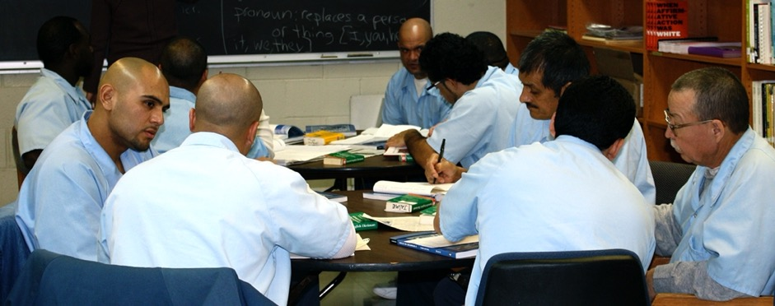

The way we started Language Partners was because there was a need. We saw a need. … I used to see guys that wanted to get into school, but they couldn’t get into school because of language, the lack of language.

- Ramon Cabrales (LP Founder, LP Teacher)

The mission of the Education Justice project is to build a model college-in-prison program that demonstrates the positive impacts of higher education upon incarcerated people, their families, the neighborhoods from which they come, the host institution, and society as a whole.

What is the Language Partners program?
Language Partners (LP) is an award-winning, peer-taught, English language program at Danville Correctional Center serving a primarily Latinx population. Our mission is to create a model ESL-in-prison program that fosters individual empowerment through a reciprocal learning community. This entails increasing the learner’s ability to communicate with others, enriching student’s connections with family members, encouraging both students and instructors to further their educational pursuits, and as a matter of social justice, challenging cultural barriers and social stereotypes.

LP offers interactive English language instruction for three hours, twice a week. Classes are mainly taught by peer instructors, providing them opportunities to develop leadership and teaching experience.

Who Can Apply?
EJP's Language Partners Program is currently accepting applications for instructor-trainers at Danville Correctional Center. Instructor-trainers serve as support for the peer instructors and help to guide and design this instructional program. If you are interested in topics related to Latinx populations, the process of teaching, designing ESL materials, or language learning, then LP program is for you.
We welcome applications from all qualified applicants. However, because EJP aims to create a supportive learning environment for our incarcerated students, we especially encourage applications from individuals whose backgrounds align with those of our students. This includes members of racial minority groups, first-generation degree holders, and individuals from low socioeconomic status backgrounds. Please note that the educational offices are on the second floor of the prison and that there is no elevator. Our main criteria in selecting LP instructor-trainers is seriousness of purpose, flexibility, and maturity.

According to Illinois Department of Corrections (IDOC) policy, if you are formerly incarcerated within Illinois or are actively visiting a friend or family who is incarcerated in IDOC, it is unlikely you will be able to receive IDOC clearance. Unfortunately, this is beyond our control.

COVID-19 Update
We are happy to announce that we plan to offer in-person programming for the 2022-2023 academic year! EJP is implementing the following safety precautions:

- Vaccination – Members submit proof of vaccination, or weekly COVID-19 test results (required by EJP);
- Temperature checks – Temperature checks occur at the front gate (required by the prison);
- Masks – The prison requires that each volunteer wears the mask provided at the front gate. EJP encourags you to double mask, by wearing your own mask, brought from home, on top of the one supplied by the prison;
- Social Distancing – Members maintain 3-feet social distancing at the prison (required by EJP).
Please be aware that in-person programming at the program is dependent on the status of COVID-19. EJP, the University of Illinois, or the Department of Corrections may decide to suspend programming as deemed appropriate for the safety of our members and/or incarcerated individuals. Thanks for your flexibility and understanding!

What would I do on a typical LP night?
We ask all LP members to attending sessions at the Danville Correctional Center (DCC) seven times a semester, or about twice per month. LP meets Tuesdays and Thursdays from 5-8pm, with our carpool typically leaving Urbana at 4:00pm and arriving back at 9:00pm. As part of your role, you are also asked to engage in the following ways:

- Attending LP sessions at DCC every two weeks (~ 7 times per semester)
- Meeting periodically for planning meetings (on campus or at DCC)
- Staying on top of EJP/LP communication efforts (e.g., reading/replying to emails regarding LP, writing and posting LP session summaries, reading EJP updates as appropriate)
- Participating in at least one EJP-wide activity, namely attending a Critical Conversation once per academic year (we would let you know when these are available!)
- Preparing or gathering teaching resources, periodically
- Contributing to an inclusive LP community culture

How to Apply
We very much want to learn about you and your experiences. Please submit the following materials online: application, a copy of your CV, and two references.

Interviews will be held as soon as possible after the receipt of materials. If you are selected to be a Language Partner, you will be required to complete clearance paperwork and attend orientation at the prison and on campus.

Please submit an application and copy of your resumé or CV to the EJP Online Application Submission point by October 3, 2022. Early submissions are welcomed and encouraged. Feel free to contact Amber Dunse or Kacie Gastañaga, LP Coordinators (LP@educationjustice.net) with questions.

For more information, visit the following resource links:
Video: Presentation for the Violence and Incarceration Community Conversation, 2013.
(Apologies, this video is uncaptioned)
Publication: Prisoners teaching ESL: A learning community among “Language Partners (PDF)

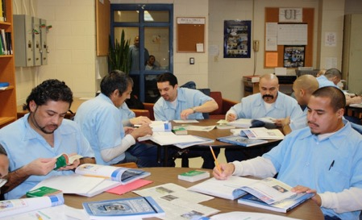
The camaraderie among the LPs and TPs was what I think is the most positive aspect of the program because it makes the LPs feel like they are in a safe place where they will not be criticized for practicing the use of English.

- Anastacio Esparza (LP Teacher)

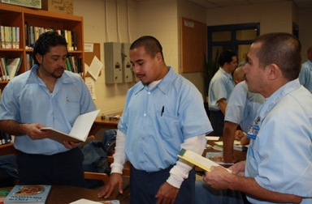

There is still so much to work on, but I am trying to reach the goal where I can communicate with others in English. [...]
I would like to take advantage of all knowledge to help others that are in the same situation that I was in. If I have the opportunity to do it here, I will do it in the time I have left.

- Francisco Castillo (LP Student)

