Education Justice Project

Language Partners Application, due March 1, 2022
Return to Amber Dunse or Kacie Gastanaga, LP Coordinators at LP@educationjustice.net

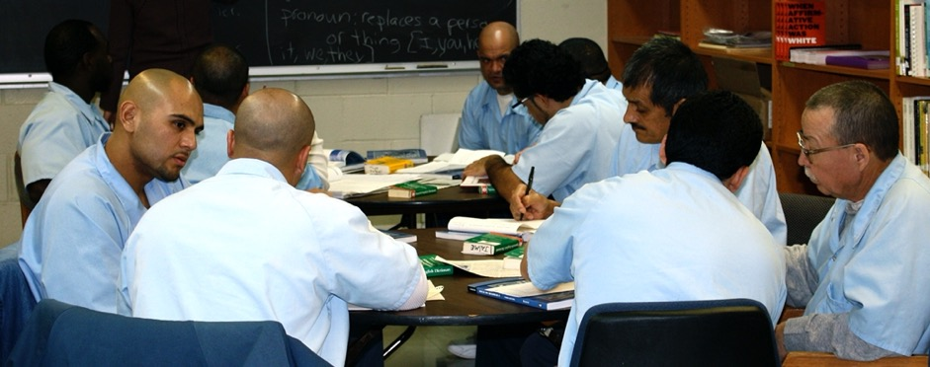

The way we started Language Partners was because there was a need. We saw a need. … I used to see guys that wanted to get into school, but they couldn’t get into school because of language, the lack of language.

- Ramon Cabrales (LP Founder, LP Teacher)

The mission of the Education Justice project is to build a model college-in-prison program that demonstrates the positive impacts of higher education upon incarcerated people, their families, the neighborhoods from which they come, the host institution, and society as a whole.

Thank you for your interest in the Education Justice Project. There are many opportunities to volunteer for worthy projects on campus and in the community. We are very grateful you have expressed an interest in our program.

What Is Language Partners?

Language Partners (LP) is an award-winning, peer-taught, English as second language program at Danville Correctional Center serving a primarily Latinx population. Our mission is to create a model ESL-in-prison program that fosters individual empowerment through a reciprocal learning community. This entails increasing the learner’s ability to communicate with others, enriching student’s connections with family members, encouraging both students and instructors to further their educational pursuits, and as a matter of social justice, challenging cultural barriers and social stereotypes.

LP offers interactive English as a Second Language instruction for three hours, twice a week. Classes are mostly taught by peer instructors, providing them with opportunities to develop leadership and teaching experience.

Who Can Apply?

EJP's Language Partners Program is currently accepting applications for instructor-trainers at Danville Correctional Center. Instructor-trainers serve as support for the peer instructors and help to guide and design this instructional program. If you are interested in topics related to Latinx populations, the process of teaching, learning or designing ESL materials, or language learning, then LP program is for you.

We welcome applications from all qualified applicants. We especially encourage applications from individuals with disabilities, members of historically underrepresented racial groups, first-generation college graduates, and post-traditional students. Please note that the educational offices are on the second floor of the prison and that there is no elevator. Our main criteria in selecting LP instructor-trainers is seriousness of purpose, flexibility, and maturity.

How to Apply

Complete this application electronically. That will allow you to take as much space as you need in responding to each question; we very much want to learn as much as we can about you. Please submit the application (pg. 4-5), a copy of your CV, and two references. Interviews will be held as soon as possible after the receipt of materials. If you are selected to be a Language Partner you will be required to complete clearance paperwork and attend orientation at the prison and on campus.

Please submit application and CV to
Amber Dunse and Kacie Gastanaga (LP@educationjustice.net) by March 1, 2022. Early submissions are welcomed and encouraged.

COVID-19 Update
We are happy to announce that we plan to offer in-person programming for the 2021-22 academic year! EJP is implementing the following safety precautions:

- Vaccination –submit proof of vaccination and a booster shot, or weekly COVID-19 test results (required by EJP);
- Temperature checks – at the front gate of the prison (required by the prison);
- Masks – prison requires that each volunteer wears the mask provided at the front gate. We encourage you to double mask, by wearing your own mask, brought from home, on top of the one supplied by the prison (required by both EJP and the prison);
- Social Distancing – 3-feet social distancing at the prison (required by EJP).
Please be aware that in-person programming at the program is dependent on the status of COVID-19. EJP, the University of Illinois, or the Department of Corrections may decide to suspend programming as deemed appropriate for the safety of our members and/or incarcerated individuals. Thanks for your flexibility and understanding!

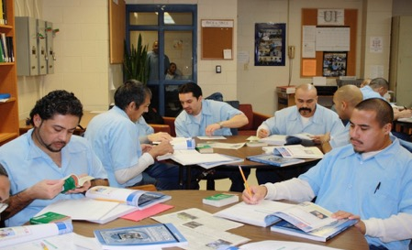

The camaraderie among the LPs and TPs was what I think is the most positive aspect of the program because it makes the LPs feel like they are in a safe place where they will not be criticized for practicing the use of English.

- Anastacio Esparza (LP Teacher)

For more information, check out the following resource links:

Language Partner Website

Video Presentation for the Violence and Incarceration Community Conversation, 2013. (Apologies, this video is uncaptioned)

Publication - Prisoners teaching ESL: A learning community among “Language Partners (PDF)

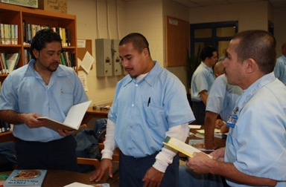

There is still so much to work on, but I am trying to reach the goal where I can communicate with others in English. [...] I would like to take advantage of all knowledge to help others that are in the same situation that I was in. If I have the opportunity to do it here, I will do it in the time I have left.

- Francisco Castillo (LP Student)

Application Form: Language Partners

Name:

Mailing Address:

Phone:

Email:

Occupation:

Employer:

Questions
Please answer the following questions.

- How did you hear about the Education Justice Project?

- Why are you interested in working with the Language Partners at Danville Correctional Center?

- Please tell us about any skills, work experiences, or volunteer experiences that you believe prepare you for working in a prison.

- Working in a prison can bring up many feelings and present a range of challenges for most of us. What do you imagine might be the biggest challenges or concerns for you?

- Please describe any subject-area or professional expertise you have that you think would be valuable to the program. Experience teaching languages is desirable, but not required.

- LP members are expected to attend 7 Language Partners sessions during the semester. Language Partners is held on Tuesday and Thursday evenings, from 5:00 – 8:00 PM (leaving UIUC by 3:45 PM and returning around 9 PM). Can your schedule accommodate those times? Let us know if you anticipate, for instance, traveling during the semester or being consistently unavailable on one of the evenings.

References
Please list two references.

CV or resumé
Please include a recent copy of your CV or resumé.

______________________________________________________________________
Your Signature (electronic or by hand)

___________________
Date

Education Justice Project
University of Illinois
1001 S. Wright St
Champaign, IL 61820
217-300-5150
(info@educationjustice.net)

