Education Justice Project
Mindfulness Discussion Group Facilitator Application
Due March 2, 2021

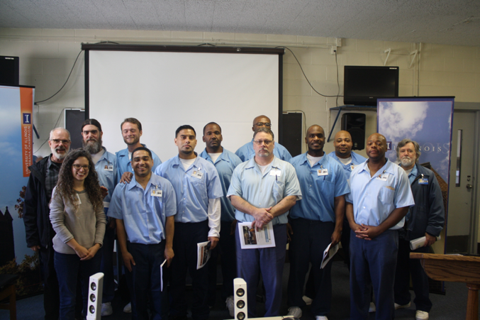
The mission of the Education Justice project is to build a model college-in-prison program that demonstrates the positive impacts of higher education upon incarcerated people, the communities from which they come, the host institution, and society as a whole.
COVID-19 Update: Due to the pandemic, EJP in-person programming at the Danville Correctional Center has been suspended since March 2020 and will remain suspended until further notice. While interested persons are highly encouraged to apply to MDG and join the EJP community please know that you will not be able to enter the prison as a volunteer until EJP and the Illinois Department of Corrections both determine that it is safe to resume in-person programming.

We are hopeful that the prison will have opened up by the time applicants are cleared for entry into the prison. While we wait, MDG is meeting virtually every month working on projects like collecting mindfulness resources for reentry and much more! We would welcome your input and support. If interested, please apply!
What is MDG?

The MDG program aims to build a positive co-created community of mindfulness meditation learners. In this community, we uphold a holistic approach to learning thus reading and discussing scholarly text is accompanied with the practice and discussion of mindfulness meditation during each meeting.

MDG meets on Thursday evenings from 5-8pm at Danville Correctional Center (DCC) including winter, spring, and summer break. To make our travel to Danville more pleasant and efficient we carpool, leaving around 4pm and returning around 9pm. About 10-15 EJP students participate in MDG each semester. Joining MDG would mean you are committing to attending our MDG meetings at DCC twice per month unless exceptions have been arranged with the co-coordinators.

What would your responsibilities be as a facilitator of MDG?

Timeframe | Responsibility
Daily | Maintain your personal meditation practice.
Monthly | Attend two MDG meetings as well as prepare and facilitate the MDG meeting’s activities as delegated (e.g., leading reading discussions, guiding meditations, etc.).
Bi-Monthly | Attend a 1-hour MDG program planning meeting on the UIUC campus.
Ongoing/Varies | Stay on top of EJP & MDG communication efforts (e.g., reading/replying to emails regarding MDG, writing and posting MDG meeting summaries on an online platform called “Mango” when assigned, reading EJP Mango reports as appropriate).  Participate in EJP outside of MDG activities, including attending at least one “critical climate” discussion per academic year (we will share more about these when we meet in person).

Beyond these responsibilities, we also expect our members to:
- Uphold an inclusive MDG community culture.
- Embody the core attitudes of mindfulness (e.g., kindness, curiosity, openness, nonjudgment) throughout all MDG activities.
- Help us think boldly and creatively about the MDG program!

What kind of prior experience do we anticipate from our MDG facilitator applicants?

Required experience:
- Personal Meditation Practice – We expect our members to possess and maintain a sincere personal meditation practice that includes daily meditation practice.
Preferred experience (however, don’t let these keep you from applying!):
- Group Facilitation Skills – Experience leading small groups in a learning environment (e.g., teaching at a school or university, in courses you have taken, leading therapy-related groups, facilitating small church discussion groups, or other group facilitation experience where there is open dialogue and perhaps sensitive topics are discussed and facilitated by you).
- Formal Meditation Training/Experience – Experience taking formal mindfulness meditation classes such as an 8-week/20-hour secular meditation class (e.g., Psychological Service Center, (PSC) 20-hour Mindfulness Training), or regular attendance with a meditation group within a particular tradition for at least 6 months (e.g., Prairie Sangha, Prairie Zen Center). If you haven’t done one of these options, we can talk about how you can get this experience in a way that is accessible to you!
Please apply!

All applications are welcome. However, because EJP aims to create a supportive learning environment for our incarcerated students, we especially encourage applications from individuals whose backgrounds align with those of our students. This includes members of racial minority groups, first-generation degree holders, and individuals from low socioeconomic status backgrounds.

After we receive your form, we will contact you to discuss your application. Those who are accepted to work with MDG will be required to complete a lengthy clearance process by the Illinois Department of Corrections, a training session at Danville Correctional Center, and a half-day EJP training session on campus. Thank you, again. We look forward to receiving your application.

Questions?

If you would like to talk to someone about MDG prior to applying please email co-coordinators Dave Sharpe and Ellen Ritter at dmsharpe13@gmail.com and ellen.s.ritter@gmail.com.
Spring 2021 Application Form
Education Justice Project
Mindfulness Discussion Group
(Due March 1, 2021)

Please complete this form in a word processing program to give you plenty of space to adequately answer the questions. Send it as an attachment to the Co-coordinators of EJP’s Mindfulness Discussion Group: David Sharpe dmsharpe13@gmail.com & Ellen Ritter ellen.s.ritter@gmail.com. Thank you!
Name:
Email:
Phone:
Mailing Address:
Submission Date:
How did you hear about the Education Justice Project?

Why are you interested in working with EJP and, specifically, in becoming a facilitator of the Mindfulness Discussion Group?
Please tell us about your meditation and mindfulness experience (e.g., tell us about the meditative tradition(s) you have studied/practiced; tell us about any meditation classes you have taken; describe your current meditation practice; tell us about any experience you have in teaching meditation).
Please tell us about any experience you may have facilitating group discussions (e.g., teaching at a school or university, in courses you have taken, leading therapy-related groups, facilitating small church discussion groups, or other group facilitation experience where there is open dialogue and perhaps sensitive topics are discussed and facilitated by you).
Working in a prison brings up many feelings and presents a range of challenges for most of us. What do you imagine might be the biggest challenges or concerns for you?
Do you anticipate that you would be able to participate in MDG at least biweekly?
Is there anything else that you would like us to know about you?
Please include the names and contact information of two references.

Education Justice Project
1001 S. Wright Street
Champaign, IL 16820
217-300-5150
info@educationjustice.net
www.educationjustice.net

